

## UNIVERSITY OF MUMBAI

# DEPARTMENT OF COMPUTER SCIENCE

PROJECT REPORT ON

**Transaction Management System**

 SUBMMITTED BY

**Mr. Shekade Dnyaneshwar Vitthal**

UNDER THE GUIDANCE OF

**Ms.Swati RajeshKumar Mourya**

TO

UNIVERSITY OF MUMBAI

IN PARTIAL FULLFILMENT OF

F.Y.M.sc.(COMPUTER SCIENCE)

SEM-1st

ACADEMIC YEAR 2021-2022

## UNIVERSITY OF MUMBAI

# DEPARTMENT OF COMPUTER SCIENCE

# Vidya Nagari, Kalina, Santacruz East, Mumbai, Maharashtra 400098



**CERTIFICATE**

This is to certify that “**Mr. Shekade Dnyaneshwar Vitthal**” Examination Roll No-**69** Student of DEPARTMENT OF COMPUTER SCIENCE, UNIVERSITY OF MUMBAI   has successfully completed the project work entitled **“Transaction Management System**” during the academic year 2020-2021. In partial fulfilment of the requirement for the award of Degree in Masters of Computer Science under University of Mumbai.

It is further certified that student completed all required phases of project.

**PLACE**: Mumbai

**DATE**: ________

____________                                                                             __________________

**PROJECT GUIDE                                                                   Head of DEPARTMENT**

(Ms.Swari RajeshKumar Mourya )                                           (Ms. Jaya Bharti )

______________________

**INTERNAL EXAMINAR**

**ACKNOWLEDGEMENT**

A project is always a result of the amalgamation of various ideas and support from countless people. I would like to acknowledge the contribution made by them. I am glad to represent my project on **“**Transaction Management System**”** This project has been a learning and challenging process for me.

I express my sincere thanks to Ms. Swati RajeshKumar Mou rya also express my thanks to **Classmates and** staff of the Computer Science Section/Department. I would like to thank my Sister for her encouragement and guidance, which helped me in completing the project.

I immensely grateful to all those because without their inspiration, constant prompting and useful suggestions.

I sincerely appreciate the help provided by those in the careful preparation of the project.

Sincere thanks from,

Mr. Shekade Dnyaneshwar Vitthal.

**INDEX**

|  |  |  |
| --- | --- | --- |
| Sr.No | Topics | Page |
|  |  |  |
| 1 | Introduction |  |
| 2 | ER Diagram |  |
| 3 | Tables-Data Dictionary |  |
| 4 | Code Of Project |  |
| 5 | Screenshot of the Outputs |  |
| 6 | Limitation Of Project |  |
| 7 | Conclusion |  |

**ER Diagram**

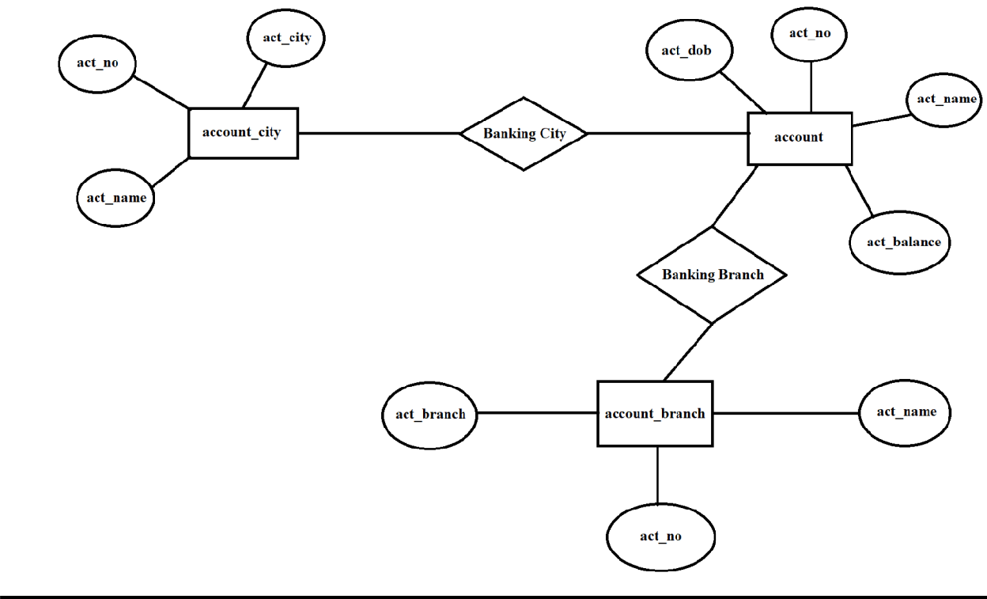

**Tables-Data Dictionary**

account table

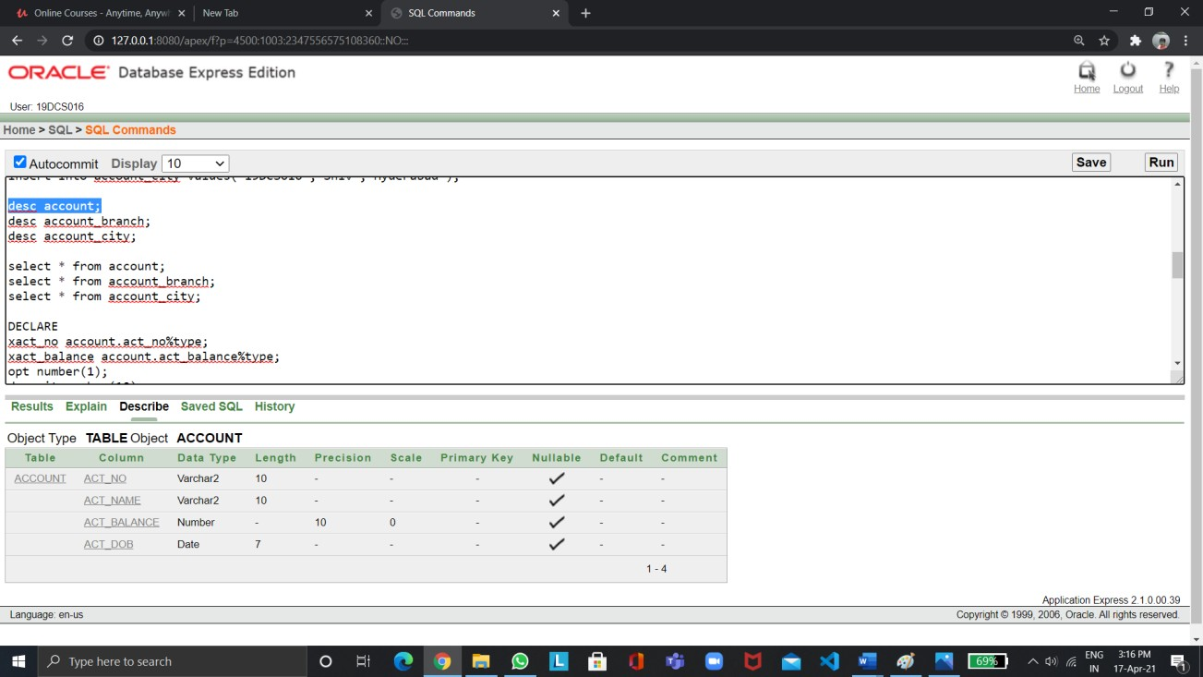

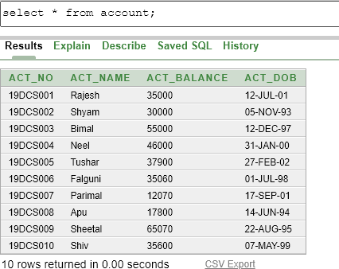

account_branch

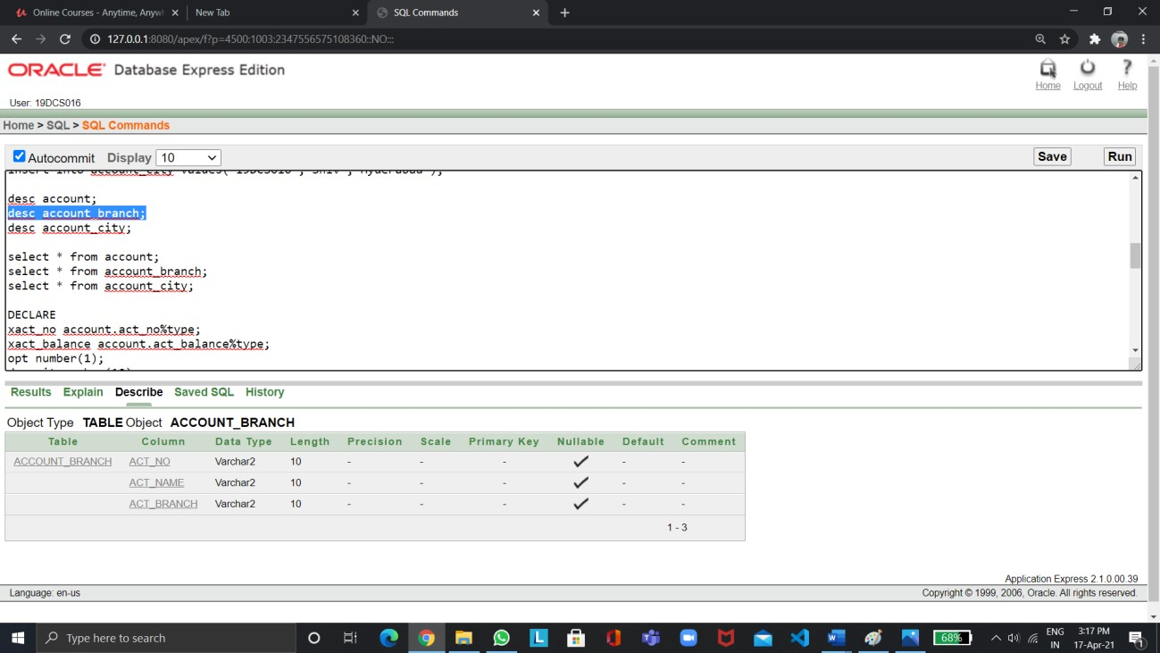

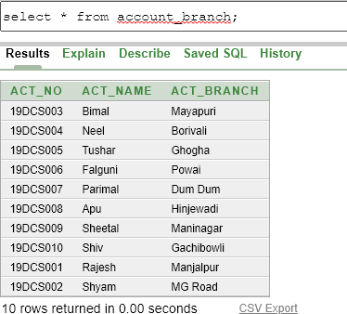

account_city

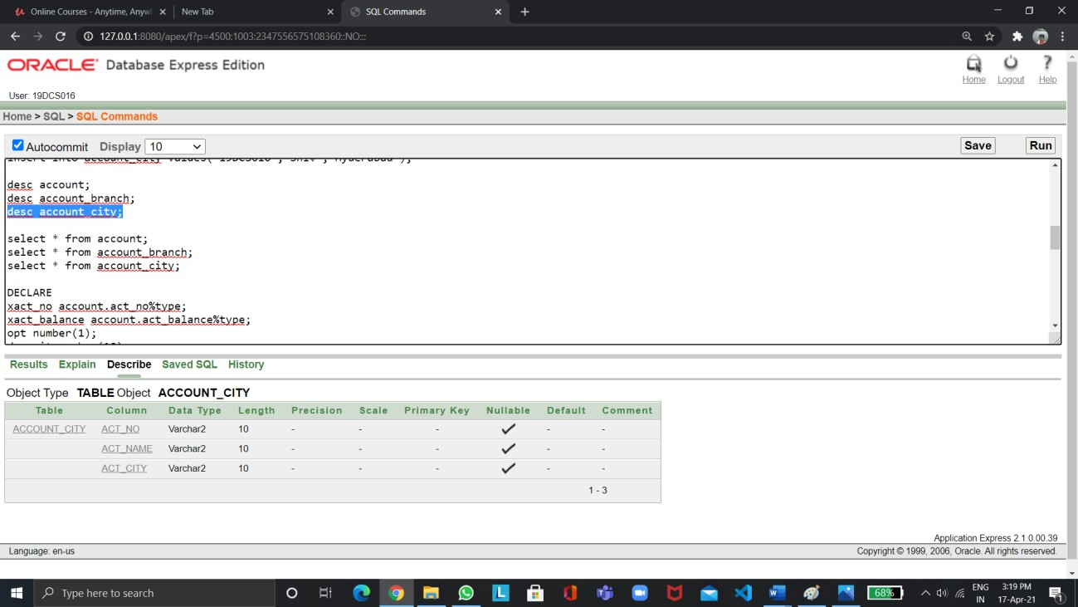

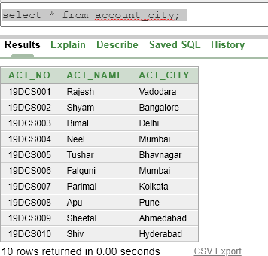

**Code Of Project**

create table account(act_no varchar2(10), act_name varchar2(10), act_balance number(10), act_dob date);

create table account_branch(act_no varchar2(10), act_name varchar2(10), act_branch varchar2(10));

create table account_city(act_no varchar2(10), act_name varchar2(10), act_city varchar2(10));

insert into account values('19DCS001','Rajesh','35000','12-JUL-2001'); insert into account values('19DCS002','Shyam','30000','05-NOV-1993'); insert into account values('19DCS003','Bimal','55000','12-DEC-1997'); insert into account values('19DCS004','Neel','46000','31-JAN-2000'); insert into account values('19DCS005','Tushar','37900','27-FEB-2002'); insert into account values('19DCS006','Falguni','35060','01-JUL-1998'); insert into account values('19DCS007','Parimal','12070','17-SEP-2001'); insert into account values('19DCS008','Apu','17800','14-JUN-1994'); insert into account values('19DCS009','Sheetal','65070','22-AUG-1995'); insert into account values('19DCS010','Shiv','35600','07-MAY-1999'); insert into account_branch values('19DCS001','Rajesh','Manjalpur'); insert into account_branch values('19DCS002','Shyam','MG Road'); insert into account_branch values('19DCS003','Bimal','Mayapuri'); insert into account_branch values('19DCS004','Neel','Borivali');

insert into account_branch values('19DCS005','Tushar','Ghogha'); insert into account_branch values('19DCS006','Falguni','Powai'); insert into account_branch values('19DCS007','Parimal','Dum Dum'); insert into account_branch values('19DCS008','Apu','Hinjewadi');

insert into account_branch values('19DCS009','Sheetal','Maninagar'); insert into account_branch values('19DCS010','Shiv','Gachibowli'); insert into account_city values('19DCS001','Rajesh','Vadodara'); insert into account_city values('19DCS002','Shyam','Bangalore'); insert into account_city values('19DCS003','Bimal','Delhi');

insert into account_city values('19DCS004','Neel','Mumbai'); insert into account_city values('19DCS005','Tushar','Bhavnagar'); insert into account_city values('19DCS006','Falguni','Mumbai'); insert into account_city values('19DCS007','Parimal','Kolkata'); insert into account_city values('19DCS008','Apu','Pune');

insert into account_city values('19DCS009','Sheetal','Ahmedabad'); insert into account_city values('19DCS010','Shiv','Hyderabad');

desc account;

desc account_branch; desc account_city;

select * from account;

select * from account_branch; select * from account_city;

DECLARE

xact_no account.act_no%type; xact_balance account.act_balance%type;

opt number(1); deposit number(10);

withdrawal number(10);

BEGIN

xact_no:= :Enter_Account_Number; opt:= :1Deposit_2Withdrawal_3Balance; select act_balance into xact_balance from account

where act_no=xact_no ;

IF( opt = 1 ) THEN

deposit:= :Enter_Deposit_Amount; update account

set act_balance=act_balance+deposit where act_no=xact_no ;

xact_balance :=xact_balance +deposit;

dbms_output.put_line('Rs. '||deposit||' has been creadited in your account'); dbms_output.put_line('Your final balance is Rs. '||xact_balance );

ELSIF( opt = 2 ) THEN

withdrawal:= :Enter_Withdrawal_Amount; IF ( withdrawal<=xact_balance ) THEN

update account

set act_balance=act_balance-withdrawal where act_no=xact_no ;

xact_balance:=xact_balance -withdrawal;

dbms_output.put_line('Rs. '||withdrawal||' has been debited in your account'); dbms_output.put_line('Your final balance is Rs.'||xact_balance );

ELSE

dbms_output.put_line('Your withdrawal amount is greater than balance'); dbms_output.put_line('Your transaction failed'); dbms_output.put_line('Your final balance is Rs.'||xact_balance );

END IF;

ELSE

dbms_output.put_line('Your balance is Rs. '||xact_balance ); END IF;

END;

# Screenshot of the Outputs

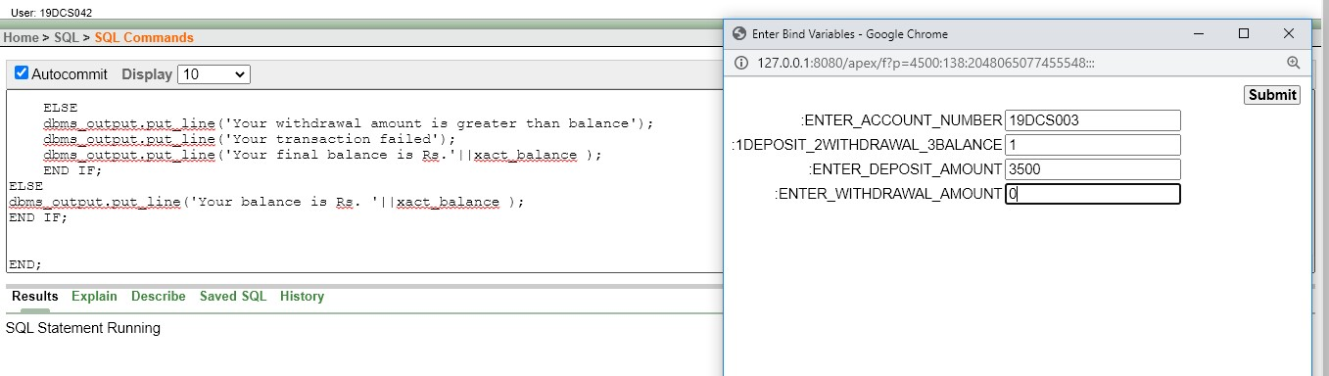

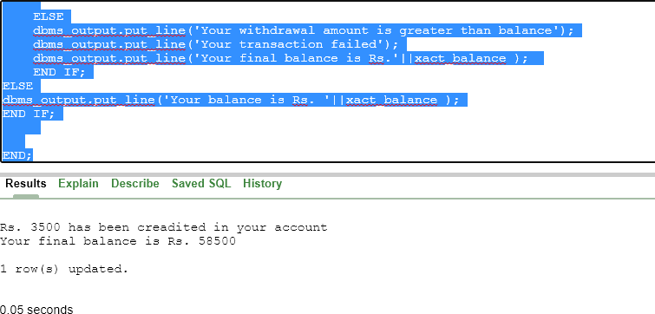

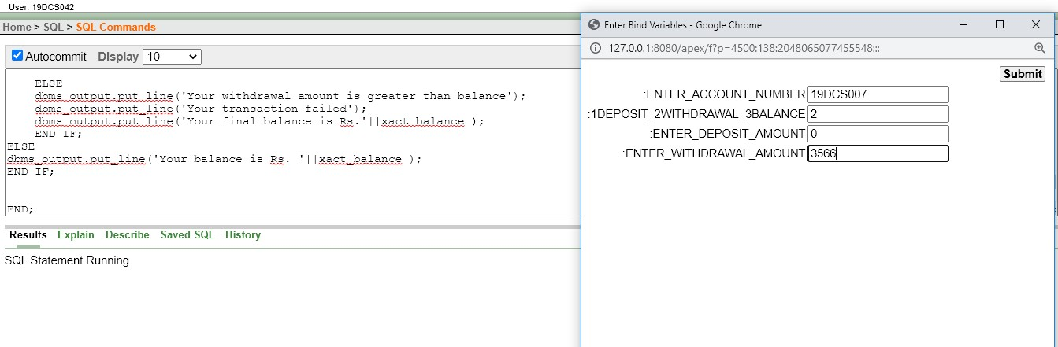

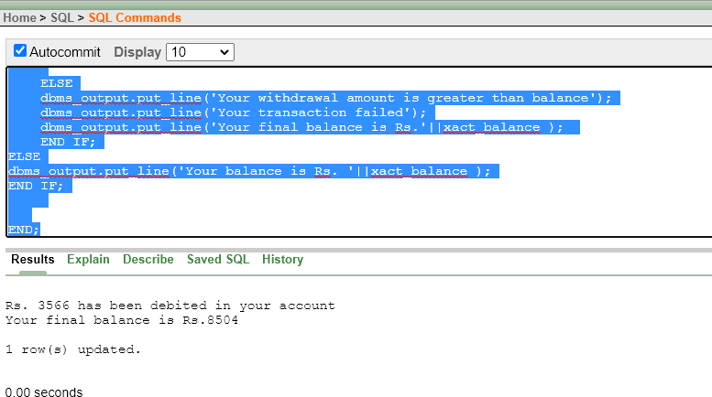

**If you do not enter deposit amount or withdrawal amount then it will show your balance according to your account number**

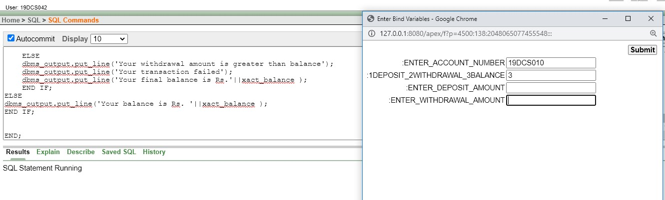

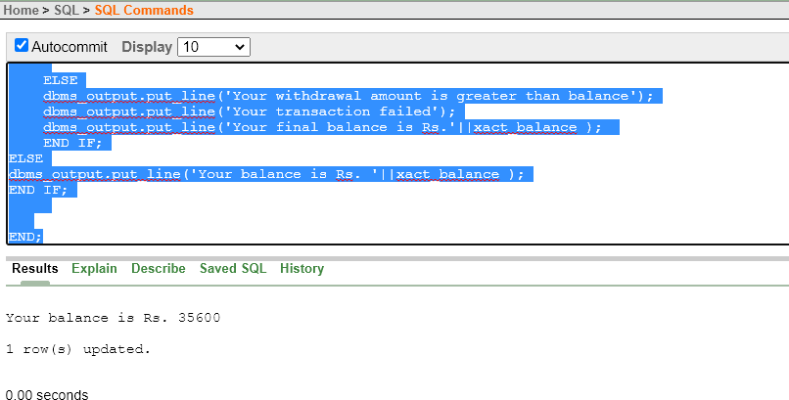

**Limitation Of Project**

It will ask for both Deposit and withdrawal amount at the same time but first we have asked for the number to choose - 1 for Deposit, 2 for Withdrawal and 3 for Checking the balance hence it will overcome it.

**Conclusion**

From this project we have learned about how to use PL/SQL and all its concepts.